

Installation, Operation and Maintenance Manual for

Pressure/Vacuum Relief Valve-Pipe Away (Weight loaded)

**Model 12F**

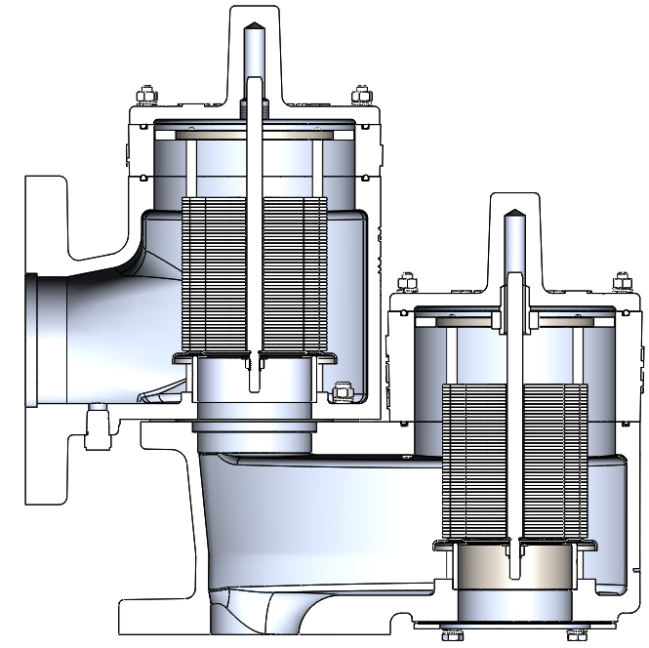

**TABLE OF CONTENTS**

**SAFETY WARNINGS 3**

**INTRODUCTION 4**

**INSTALLATION 5**

**DESIGN AND FUNCTION 8**

**MAINTENANCE 9**

**MODEL NUMBER IDENTIFICATION 11**

**PRODUCT LIMITED WARRANTY 12**

## **SAFETY WARNINGS**

## **THIS SECTION IS AN OVERVIEW OF SAFETY GUIDELINES THAT SHOULD BE FOLLOWED DURING THE INSTALLATION, OPERATION AND MAINTENANCE OF PRESSURE/VACUUM RELIEF VALVES.TO UNDERSTAND THE CONTEXT OF THESE INSTRUCTIONS AND WARNINGS, IT IS NECESSARY TO COMPLETELY READ AND UNDERSTAND THE CONTENTS OF THIS MANUAL. THE PURPOSE OF A WEIGHT LOADED PRESSURE/VACUUM RELIEF VALVE IS TO PREVENT EXCESSIVE PRESSURE/VACUUM IN A TANK OR PROCESS SYSTEM. THE VALVE MUST BE DESIGNED FOR THE PROPER MAXIMUM ALLOWABLE WORKING PRESSURE (MAWP) AND FLOW REQUIREMENTS OF THE SYSTEM.CONSULT API STANDARD 2000, ISO 28300, OR LOCAL REGULATIONS FOR TANK PROTECTION SIZING PROCEDURES. AN IMPROPERLY SPECIFIED OR FUNCTIONING RELIEF VALVE MAY RESULT IN STRUCTURAL DAMAGE TO THE TANK OR SYSTEM AND CAN CAUSE SEVERE PERSONAL INJURY OR DEATH. VALVES ARE SET AT THE FACTORY ACCORDING TO PURCHASE ORDER SPECIFICATIONS.DO NOT CHANGE PRESSURE RATINGS BY ADDING ADDITIONAL WEIGHTS TO THE PALLET ASSEMBLY WITHOUT CONSULTING THE FACTORY OR YOUR LOCAL GROTH REPRESENTATIVE.ADDING WEIGHTS TO A VALVE MAY RESTRICT PALLET LIFT AND REDUCE THE VALVE’S RATED FLOW CAPACITY. DO NOT MIX PRESSURE/VACUUM PALLET ASSEMBLIES.FAILURE TO ENSURE THAT BOTH PALLET ASSEMBLIES ARE INSTALLED IN THE CORRECT LOCATION CAN CHANGE THE PRESSURE AND VACUUM RELIEF SETTINGS OR RESTRICT LIFT OF THE PALLET.THIS CAN CAUSE A TANK FAILURE. DO NOT ATTEMPT TO REMOVE THE VALVE FROM THE TANK OR PROCESS VESSEL WITHOUT FIRST BLEEDING ALL PRESSURE FROM THE SYSTEM.ALTERNATIVE MEANS OF PRESSURE RELIEF MUST BE PROVIDED WHEN THE VALVE IS OUT OF SERVICE. IF THE VALVE HAS BEEN EXPOSED TO PROCESS VAPORS WHILE IN SERVICE, OBSERVE ALL PLANT PROCEDURES AND MATERIAL SAFETY DATA SHEETS (MSDS) FOR THE PRODUCTS IN THE SYSTEM WHEN INSPECTING, ADJUSTING OR SERVICING THE VALVE.TAKE APPROPRIATE SAFETY PRECAUTIONS REGARDING EYE PROTECTION, RESPIRATION AND SKIN CONTACT. THE TANK PRESSURE REQUIRED TO DISCHARGE THE NORMAL OR EMERGENCY VENTING REQUIREMENTS OF THE TANK WILL BE INCREASED BY THE AMOUNT OF BACK PRESSURE IN THE DISCHARGE HEADER, ON A PIPE AWAY VALVE CONFIGURATION. MAXIMUM POSSIBLE DISCHARGE HEADER PRESSURE MUST BE CONSIDERED WHEN SIZING THE PRESSURE RELIEF VALVE.**

# INTRODUCTION

Pressure and/or vacuum relief valves are used on liquid storage tanks and other process vessels or systems to prevent structural damage due to excess internal pressure or vacuum.

Storage tanks are pressurized when liquid is pumped in, compressing the existing vapor or when rising temperatures cause increased evaporation or expansion of existing vapor.Conversely, a vacuum condition may be created when pumping out or due to falling temperature.To prevent tank damage, vapor must be allowed into or out of the tank at specified pressure/vacuum conditions. The volume rate of venting depends upon the tank size, volatility of the tank contents, the pumping rates and the temperature. Refer to API Standard 2000, ISO 28300, or local regulations for the procedures to determine venting requirements.

A relief valve must be carefully maintained by a qualified valve technician. It should only be assembled under clean conditions, preferably in a service shop environment. Carefully read and understand this manual before installing or attempting to repair a valve.

For information not contained in this manual, please contact:

|  |
| --- |
| *Groth Corporation 13650 N. Promenade Blvd. Stafford, TX, 77477 USA Phone: 281-295-6800 Fax: 281-295-6999 www.grothcorp.com* |

# 

# INSTALLATION

## 

#### A typical valve installation on a tank or vessel is illustrated in Figure 1, using a Model 12F Pressure/Vacuum Relief Valve-Pipe away. Groth's weight loaded Pressure/Vacuum Relief Valves are designed to provide tank protection for pressure/vacuum up to 24 OSIG settings. The valves provide full rated flow capacity at 100% over-pressure. Consult factory for performance under other conditions.

### WARNING: The valve must be installed in a vertical position as shown in Figure 1. To achieve nominal flow capacity, the tank nozzle bore must be at least the same nominal dimension as the relief valve inlet body.

### The following considerations need to take care while lifting valve:

#### Never change the provided Pre-set locations of eye nuts/eye bolts.

1. For best stable control, Keep the CG (Centre of gravity) contained with three or four adjustable sling legs. See Figure 2 (a).
2. Always keep angle of lifting more than 60 degree from horizontal surface for each individual sling for stable lifting. See Figure 2 (a).

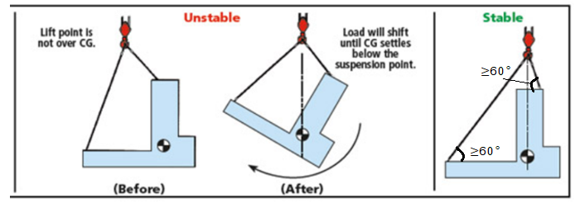

**Figure 2 (a)– Valve lifting considerations**

1. Always use adjustable chain slings to make stable lifting. See Figure 2 (b).

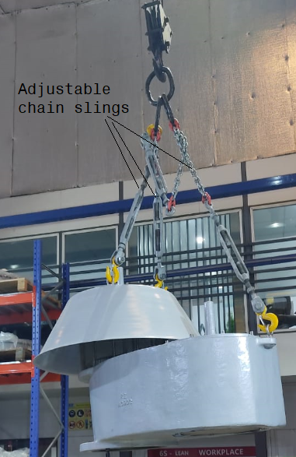

**Figure 2 (b)– stable lifting with adjustable chain slings**

### The model 12F PVRV has 150# ASME flange drilling, and torque guidelines are provided in Table 1. The model 12F valve is NOT rated for full flange pressure and do not require high bolting torque. Consult factory for special applications.

### The following guidelines should be observed at installation:

#### Inspect the gasket seating surface of the tank nozzle flange. It must be clean, flat and free of scratches, corrosion and tool marks.

### Aluminum valves are furnished with flat face flanges; they should only be installed on a mating flat face flange with a full faced gasket. Note: 1/8” thick FF non-asbestos gaskets are recommended for Aluminum and 1/16” thick FF non-asbestos gaskets for CS or SS.

### Inspect the gasket; make sure that the material is suitable for the application.

### Lubricate all studs and nuts with an appropriate thread lubricant. If the valve will see high temperature service or stainless-steel fasteners are used, apply an anti-seize compound such as moly-disulphide.

### Center the gasket within the bolt circle.

### Set the valve carefully on the nozzle. Install the studs and tighten nuts hand tight.

### Torque all fasteners to half the value listed in Table 1 in a cross torqueing pattern.

### Make sure that the flanges are not distorted, and that the gasket is evenly compressed. Make up the final torque and check that no further nut rotation occurs at the torque value specified In Table 1.

**Table 1 - Bolt Torque- 150# ASME Flange Connections\***

|  |  |  |  |
| --- | --- | --- | --- |
| Mounting | Bolt Torque – Lb-ft (N-m) | | |
| Flange | Raise Face –CS/SS | Flat Face- Alum. | Total No. of Holes |
| 2" | 30 (41) | 30 (41) | 4 |
| 3" | 46 (62) | 38 (52) | 4 |
| 4" | 30 (41) | 30 (41) | 8 |
| 6" | 55 (74) | 50 (68) | 8 |
| 8" | 72 (98) | 66 (89) | 8 |
| 10" | 70 (95) | 80 (108) | 12 |
| 12" | 87 (118) | 104 (141) | 12 |

*Use Standard ASME Bolt/Stud.

**Table 2 - Valve Weights @ Maximum Settings - Lb. (kg)**

|  |  |  |
| --- | --- | --- |
| Valve Size | 12F | |
| CS/SS | Aluminium |
| 2" | 111.8 (50.7) | 63.0 (28.6) |
| 3" | 182.4 (82.7) | 90.9 (41.2) |
| 4" | 264.7 (120.1) | 136.6 (61.9) |
| 6" | 478.2 (216.9) | 261.7 (118.7) |
| 8" | 766.2 (347.5) | 425.4 (192.9) |
| 10" | 1057.3 (479.5) | 603.4 (272.6) |
| 12" | 1437.8 (652.1) | 835.5 (378.9) |

# DESIGN AND FUNCTION

Tank protection equipment typically includes an operating valve which is designed to provide pressure/vacuum relief under normal pump in/out and thermal breathing conditions. An emergency relief valve can also provide both pressure and vacuum relief and normally it is sized to provide pressure relief if there is a fire in the immediate vicinity of the tank. It may also be sized by the tank designer to provide protection in the event of equipment failure (such as the rupture of a process steam line or an inert gas blanketing system failing “wide open”) or operator error.

### A typical tank installation is shown in Figure 1 which includes the following Groth products:

#### Model 12F Weight loaded pressure/vacuum relief valve-Pipe away

#### Model 1660A-Pilot Operated pressure relief valve

#### Model 22E Emergency pressure relief valve

Pressure Relief:

As the pressure in storage tank increases, the vacuum pallet is held shut. When the set pressure is reached, the pressure pallet lifts and relieves tank pressure to the atmosphere. See Figure 3 (a).

Vacuum Relief:

As a vacuum is drawn in the storage tank, the pressure pallet is held shut. When the set vacuum is reached, the vacuum pallet lifts and relieves tank pressure to the atmosphere. See Figure 3 (b).

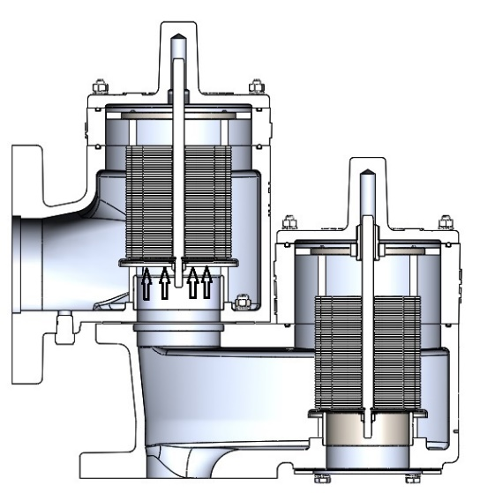 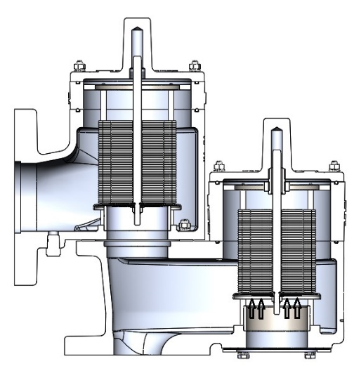

**Figure 3 (a)– Pressure Relief Figure 3 (b)– Vacuum Relief**

### INSTALLATION NOTES: (See Figure 1)

#### Minimum clearance between tank roof and vacuum inlet port must be at least equal to the valves nominal flange bore.

#### Tank nozzle bore must be greater than or equal to the valve inlet flange bore.

#### Inlet and outlet piping loads must be supported by appropriate structural supports, NOT by the valve body.

# MAINTENANCE

### Groth Corporation recommends that all service performed on a pressure/vacuum relief valve is done at a Groth Authorized Repair Dealer. Contact Groth Corporation for your local authorized repair dealer. Trained mechanics with specialized test equipment will ensure that the valve is accurately set. It is important to regularly inspect the diaphragm, guides and seating surfaces to ensure the valve can open freely. Refer to Figure 3 which illustrates a typical pressure/vacuum relief valve when disassembling the unit.

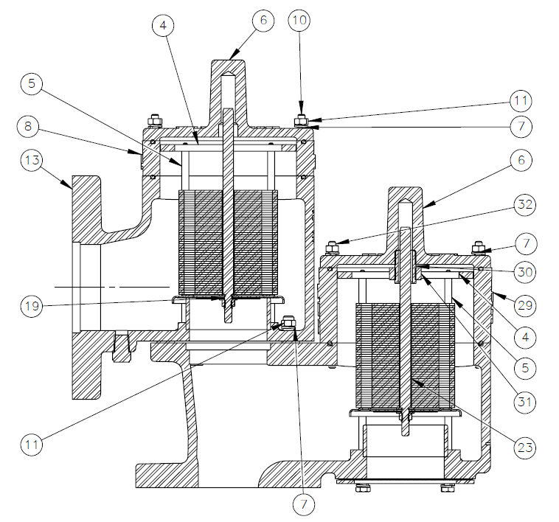

**Figure 4 - Valve Cross Section**

### WARNING: Before disassembling valve, carefully read and understand the Safety Warnings listed on page 3.

### Refer to Figure 4 for Part References

### Loosen and remove all nuts and washers (#11 and #7).

### Lift off the outlet (#13) and pressure/vacuum cover (#06). The guide plate (#4) and guide rod (#5) have a snug fit.

### Remove the pressure and vacuum pallet assemblies by firmly grasping the stem and lifting. Depending on the pressure/vacuum settings of the valve, weight plates may have been added to the pallet assemblies. The weights and pallets must be reinstalled in their original locations. Make sure that all weight plates need to be removed first and placed separately from the pallet assembly. Tag the assembly *"Pressure” and* “Vacuum “as they are removed from the valve. Take proper precaution as CS & SS weights may have been used.

#### Check the metal seating surfaces for pitting, corrosion or product build up. It is recommended to replace all soft goods including diaphragms.

#### NOTE: If the metal seating surfaces are damaged, they must be lapped using a flat ground metal disc, flatness better than 0.002", and fine grit emery cloth attached to the disc. Wipe the seating surface clean before proceeding.

### Verify that the pallets and weights are back in their proper location. Assemble in reverse order, observing the maximum dimensions for the weight blocks. Make sure that pallet assemblies sit flat on the seat and that the stem is not cocked when the Outlet (#13) installed. Tighten all nuts firmly.

#### WARNING: When assembling a Pressure/Vacuum valve, always use the correct length stem (as specified in Table 3), put the pressure and vacuum pallet assembly back in the original location and ensure that the stem is straight and fits into the guide in the outlet (#13).

#### If the stem length is too long, pallet lift will be restricted; the valve will not attain its full rated flow capacity.

#### DO NOT mix pressure/vacuum pallet assemblies. Failure to ensure that both pallet assembly are installed correctly can change the pressure and vacuum relief settings or restrict lift of the pallet. This can cause a tank failure.

# 

# MODEL NUMBER IDENTIFICATION

|  |
| --- |
|  |
| **EXAMPLE: 12FTWW0-355-00**  *Indicates 2" Model 12F, 10% over set pressure/vacuum with CS Body SS Seat and Pallet , No Options, No special Requirements.* | |

# 

# PRODUCT LIMITED WARRANTY

Seller warrants that products which are manufactured by Seller, are manufactured in accordance with published specifications and free from defects in materials and/or workmanship for a period of (12) twelve months. Seller, at its option, will repair or replace any products returned intact to the factory, transportation charges prepaid, which Seller, upon inspection, shall determine to be defective in material and/or workmanship. The foregoing shall constitute the sole remedy for any breach of Seller's warranty.

THERE ARE NO UNDERSTANDINGS, AGREEMENTS, REPRESENTATIONS, OR WARRANTIES, EXPRESS OR IMPLIED, (INCLUDING MERCHANTABILITY OR FITNESS FOR A PARTICULAR PURPOSE REGARDING PRODUCTS) UNLESS SPECIFIED IN THE SALES CONTRACT. THIS CONTRACT STATES THE ENTIRE OBLIGATION OF SELLER.

Seller makes no warranties, either express or implied, except as provided herein, including without limitation thereof, warranties as to marketability, merchantability, for a particular purpose or use, or against infringement of any patent of products. In no event shall Seller be liable for any direct, incidental or consequential damages of any nature, or losses or expenses resulting from any defective new product or the use of any such product, including any damages for loss of time, inconvenience, or loss of use of any such product.

The original Manufacturer shall be solely responsible for the design, development, supply, production, and performance of its products hereunder, and the protection of its trade name or names, if any. It assumes no responsibility, for products modified or changed in any way by its agent or customer. Any such modifications or changes to products sold by Seller hereunder shall make the product limited warranty null and void.

The Manufacturer shall be under no obligation to manufacture, sell, or supply, or to continue to manufacture, sell or supply any of the Products.

